3. Vocabulary
Vocabulary of the Unit 1
Regular Verbs
Present | Past | Future | Spanish
receive | received | Am receive? | recibir
looks |  |  | mira/busca
care | cared | I will care | cuidar
Irregular Verbs
Prensent | Past | Future | Spanish
Lay | laid | I will lay | colocar

Pumb -
Waiter /waitress - camarero
Architect - arquitectura

3.1 Jobs
What are these people’s jobs?
Listen to these people talking about their jobs. What do they do?
- Dentist
- Tour guide
- shop assistant
- Pilot
- Nurse

who is speaking?
Listen to these people speaking about their jobs choose the correct person
audio 1
Who spends his days navigating the skies?
Carlos
Who guides people through ancient buildings?
Tom
Whose job involves caring for people smile?
Emma
Who helps customers?
Sophie
Who works helps patients?
Olivia
Are they telling the truth
Emma believes that helping others with their oral health is rewading
true
tom dislike sharing stories about the city’s history
false
Sophie finds enjoyment in the livery atmosphere of the shop
true
when the weather decides to play tricks on then his jobs is very funny
true
Olivia thinks her job is fulfilling
true

3.2 Introducing yourself
Description:
learning about uses oneself expression both at work or personal information.
Watch this video and study this information
https://www.youtube.com/watch?v=QgjkjsqAzvo
1. Greetings
Formal greetings
- hello
- good morning
- good afternoon
- good evering
Informal greeting
-hey
-hi hiya
-yo what’s good?
-what’s up?
2. Your Name
I’m I am
My name
this is “name” speaking
3. Location
I’m from
I come from
I was born and raise in
I grew up in
4. Position and company
yes use at or for, no In “company” “name”
I work at “company” in the “… department”
I’m a position at “company”
General:
I work in “general area”
Specific position:
I work as a “position “
5. Qualifications
I’m about to graduate
I’m a “subject “graduate”
Example:
I’m a marketing graduate
I have a bachelor of arts degree in marketing
I‘m currently taking a course in “subject
Example:
I‘m currently taking a course in maths
use of “ on”
6. Experience
I have “number“years of experience in the“ occupation “ field
Example:
7. Family
I‘m from a family of “number”
I am one of “ number” siblings
8. Hobbies
I m a big fan hobby
9. Age
I am “number“ years old
10. Fun fac
What is he talking about?
Understanding personal information
Video: https://www.youtube.com/watch?v=R3AT8AtkeGc&t=1s
Personal and professional introductions
Listen to Laura Thompson talking about herself
[capture]
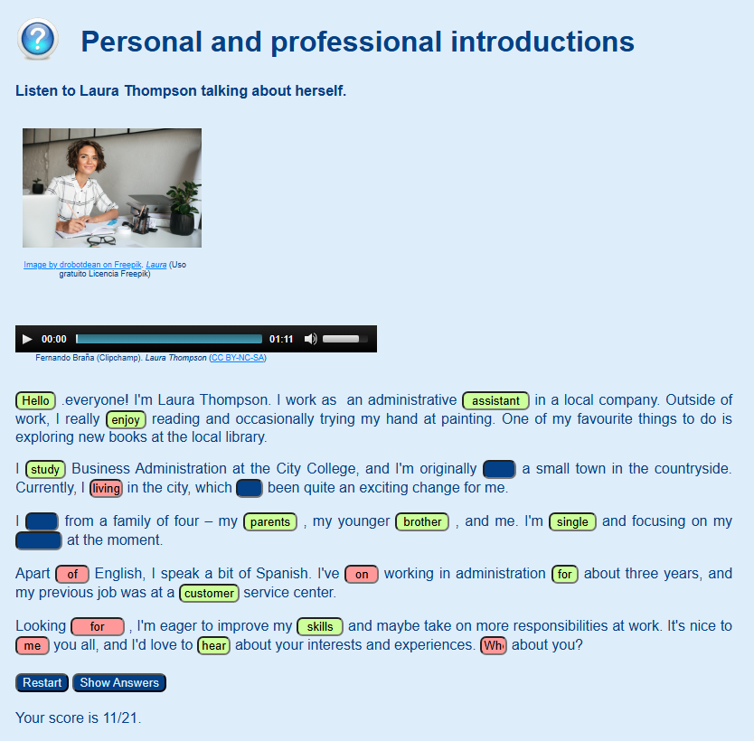

Solution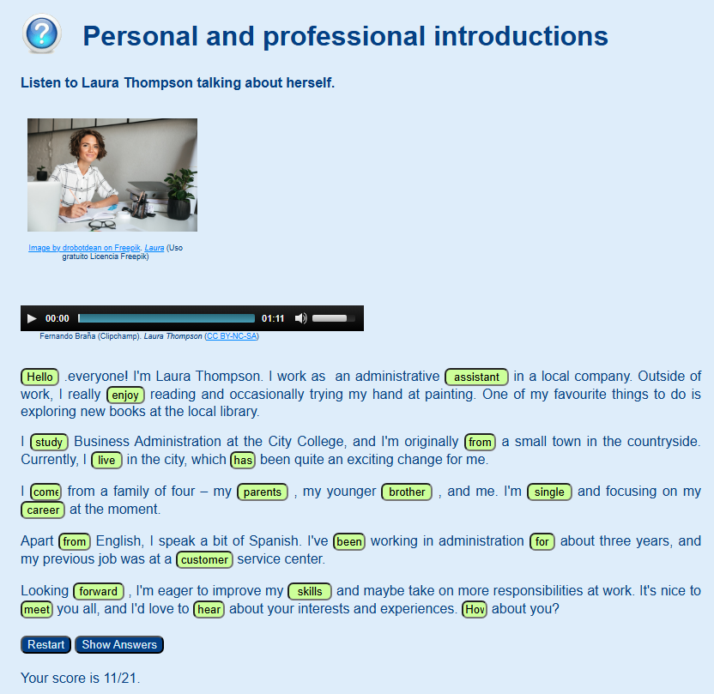

3.3 Describing yourself
Can you guess the hidden adjectives?
Ambitious
Analytical
Assertive
Cheerful
Conscientious
Creative
Dependable
Detail-oriented
Diplomatic
Energetic
Enthusiastic
Flexible
Hardworking
Knowledgeable
Loyal
Motivated
Organized
Outgoing
Polite
Productive
Professional
Reliable
Resourceful
Responsible
Can you help me find the adjectives?
Find the hidden words with the help of the definitions

4. Reading comprehension
Read this text about Emily's day at work and then complete the activities listed below
Reading Activity
What’s the correct option?
report problem
2 Exercise
Are true of false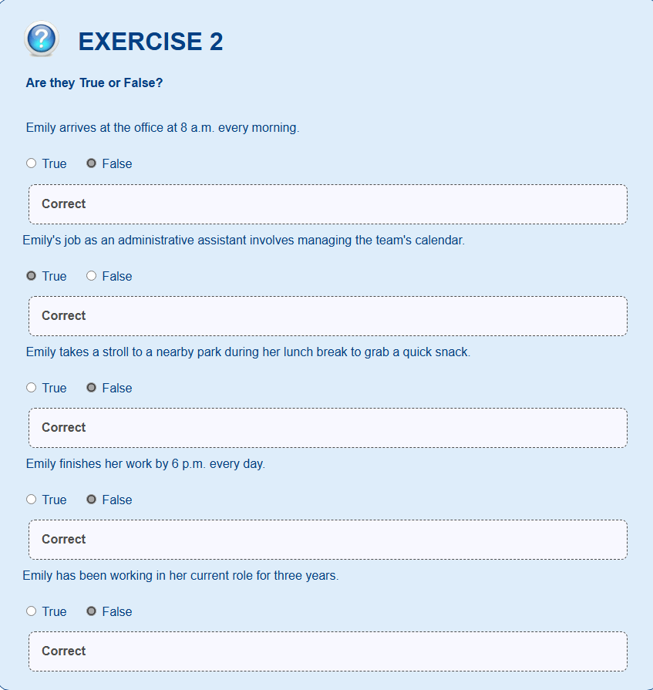
A DAY IN THE OFFICE
I work in a busy office in the heart of the city. I start my day by arriving at 9 a.m. Every morning, I greet my colleagues with a warm "Good morning" and ask how they are. I believe that a positive start to the day is essential.
My job as an administrative assistant involves handling emails, scheduling meetings, and organizing office events. I have been working in this role for two years and enjoy the variety it brings. Every day is different, and I like that
One of my main tasks is managing the calendar for the team. I ensure that everyone is aware of upcoming meetings and deadlines. I am also responsible for answering phone calls and helping visitors at the front desk.
During my lunch break, I usually take a stroll to a nearby park. It's my way of taking a break from the busy office environment and getting some fresh air. It helps me recharge for the rest of the day,
In the afternoon, I focus on completing my tasks for the day. I collaborate with my team members, and they often share a quick chat about their projects. By 5 p.m., I wrap up my work and say goodbye to my colleagues, wishing them a pleasant evening.
I enjoy my job because it allows me to stay organized and interact with different people. Every day brings new challenges, but I find it fulfilling.

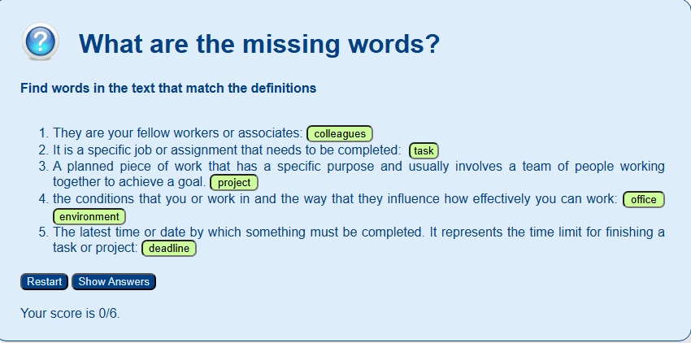
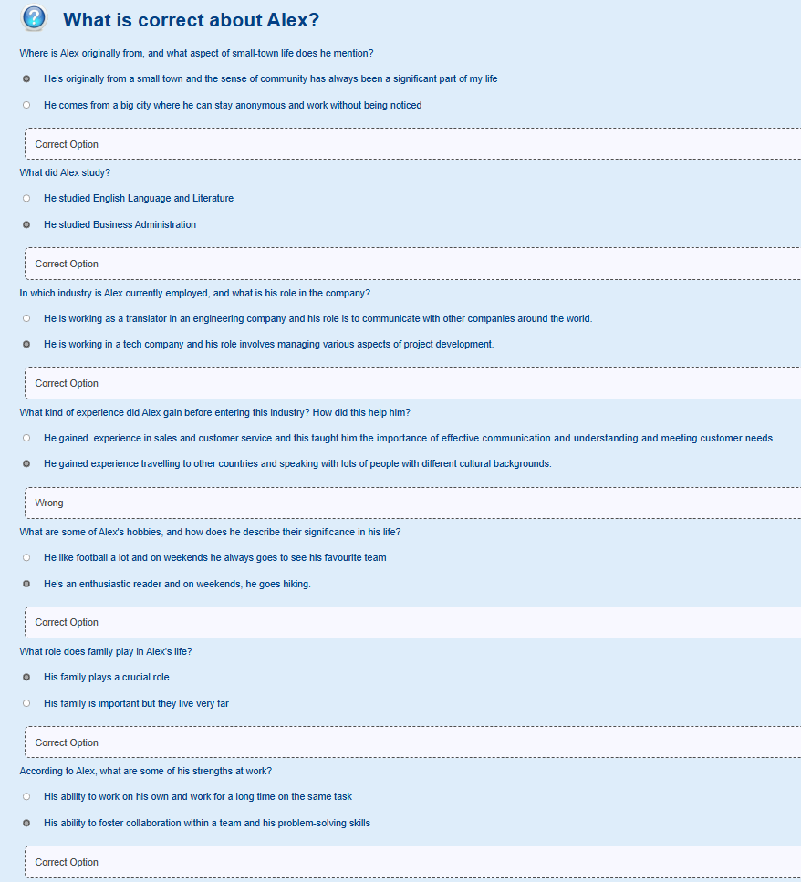
5. Listening Comprehension

